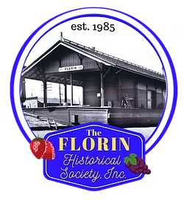
Florin Historical Society’s
Taco Bar Fundraiser
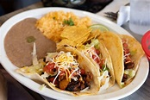

When: Saturday, April 11, 2026
Where: 7145 McComber Street,
Sacramento, CA 95828
Time: 11:30 am to 1:30 pm
Cost: $12.00, includes 2 beef or
chicken tacos, rice, beans, drink & dessert;
(you get to put on your own toppings)

Dine in or Take Out

Come support the FHS Scholarship Fund
----- cut and return RSVP by April 4, 2026----
Name ________________________________________________
Phone ______________ email ___________________________
______ Beef Tacos / ______ Chicken Tacos
Dine In _____ or Take Out _____
Total Orders _____ X $12.00 = Total Enclosed: $______
Return to:
Florin Historical Society
P.O. Box 293632, Sacramento, CA 95828
(916)692-4069

Thank you for supporting the
Florin Historical Society’s Scholarship Fund

